Project Summary: Comprehensive Analysis of the Iris Dataset Using AWS Data Pipeline and Visualization Tools

Course: CIS 602 Big Data Analytics
Instructor: Dr. Ashokkumar Patel
Student: Lizzy Dale, group no 24, roll 9

Introduction
The Iris dataset is a seminal dataset in the field of data science and machine learning, consisting of 150 samples from three Iris species: Setosa, Versicolor, and Virginica. Each sample comprises measurements of four features: sepal length, sepal width, petal length, and petal width. This dataset is instrumental in understanding data classification, clustering, and visualization techniques. The goal of this project is to develop a robust data pipeline that processes, analyzes, and visualizes the Iris dataset to explore feature correlations and facilitate species classification. We utilized AWS services, including Amazon S3, AWS Glue, Amazon Athena, and AWS QuickSight, to achieve these objectives.

Data Pipeline Overview
The data pipeline for this project involved several key stages: data ingestion and storage, data processing and transformation, data analysis, and visualization.

1. Data Ingestion and Storage
The Iris dataset was sourced from the UCI Machine Learning Repository and securely uploaded to Amazon S3. Amazon S3 provides scalable and durable storage, ensuring data availability and reliability. This step facilitates efficient data management and easy access for subsequent processing and analysis phases.

2. Data Processing and Transformation
AWS Glue Crawler
The AWS Glue Crawler was employed to automatically scan the Iris dataset in Amazon S3 and infer its schema. This process involved the detection of data format, structure, and metadata, resulting in the creation of a schema registered in the AWS Glue Data Catalog. The crawler’s automation significantly streamlined the initial data setup process, reducing manual effort in schema definition and ensuring accuracy in data representation.

Schema Customization
After schema detection, customization was performed by editing the JSON configuration in the AWS Glue interface. Column names were modified to more descriptive identifiers, aligning with data processing standards and simplifying querying and analysis phases.

3. Data Analysis Using Amazon Athena
With the schema ready in the AWS Glue Data Catalog, Amazon Athena was utilized to execute SQL queries directly against the data stored in S3. Athena's serverless architecture enabled efficient query execution without the need for additional data processing infrastructure.

Initial Table Preview
The analysis began with a preliminary query to preview the first 10 rows of the dataset, ensuring data integrity and format consistency.

SQL Query:

Insights:
- Data Verification: This query provided an overview of the data, confirming that all expected columns were present and correctly formatted.
- Preliminary Assessment: Enabled initial assessments of data completeness and quality, crucial for planning further analysis.

Descriptive Statistics Queries
Next, SQL queries were crafted to calculate key statistical metrics such as mean, median, mode, and standard deviation for the dataset's features.

SQL Query for Descriptive Statistics: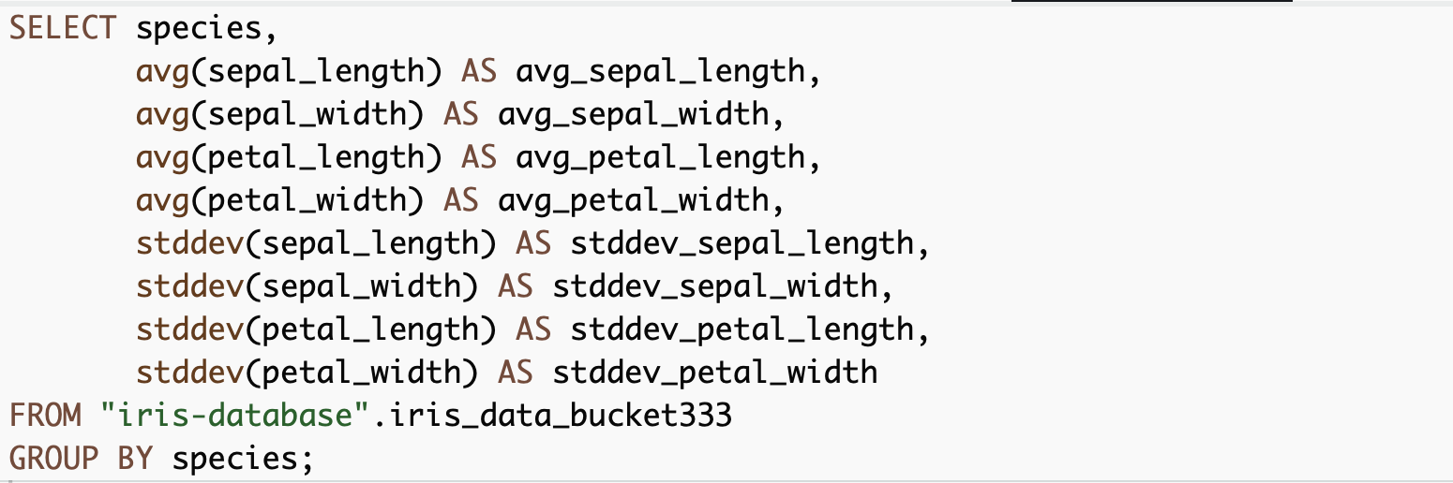

Results:
species | avg_sepal_length | avg_sepal_width | avg_petal_length | avg_petal_width | stddev_sepal_length | stddev_sepal_width | stddev_petal_length | stddev_petal_width
Iris-versicolor | 5.936 | 2.7700000000000000 | 4.26 | 1.3260000000000000 | 0.5161711470638640 | 0.3137983233784110 | 0.46991097723995800 | 0.19775268000454400
Iris-virginica | 6.588000000000000 | 2.9740000000000000 | 5.552 | 2.026 | 0.635879593274432 | 0.3224966381726380 | 0.5518946956639840 | 0.27465005563666700
Iris-setosa | 5.006000000000000 | 3.4180000000000000 | 1.464 | 0.2440000000000000 | 0.3524896872134510 | 0.38102439795469100 | 0.1735111594364460 | 0.1072095030816780
Insights:
- Central Tendencies: Calculated averages provided a baseline understanding of typical feature values for each species.
- Variability: Standard deviation offered insights into the variability within species, highlighting how consistent or diverse each species is in terms of its morphological features.

Correlation Coefficients
To understand the relationships between different features, Pearson correlation coefficients were calculated.
SQL Query for Correlation Analysis: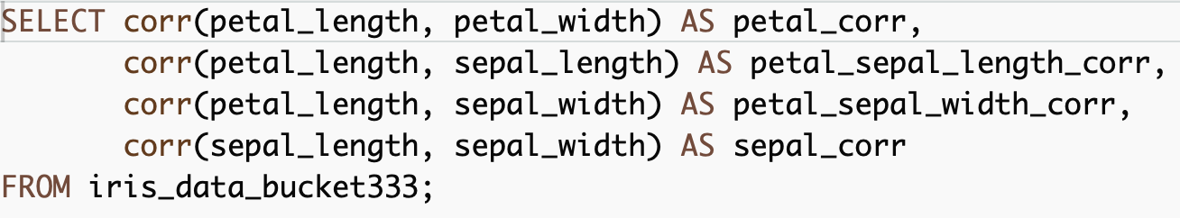
Results:
petal_corr | petal_sepal_length_corr | petal_sepal_width_corr | sepal_corr
0.9627570970509670 | 0.8717541573048720 | -0.4205160964011540 | -0.10936924995064900
Insights:
- Feature Relationships: Strong positive correlations between petal length and width indicated that as one dimension increases, the other tends to increase, suggesting coordinated growth patterns.
- Predictive Potential: Identifying which features are most closely related helps in feature selection for predictive modeling, emphasizing petal measurements as key indicators for species differentiation.
4. Visualization with AWS QuickSight
AWS QuickSight was utilized to create dynamic visualizations, enhancing understanding of the dataset through visual analysis.

Bar Chart: Sum of Measurements by Species
A bar chart was generated to display the cumulative measurements of sepal and petal dimensions for each Iris species.
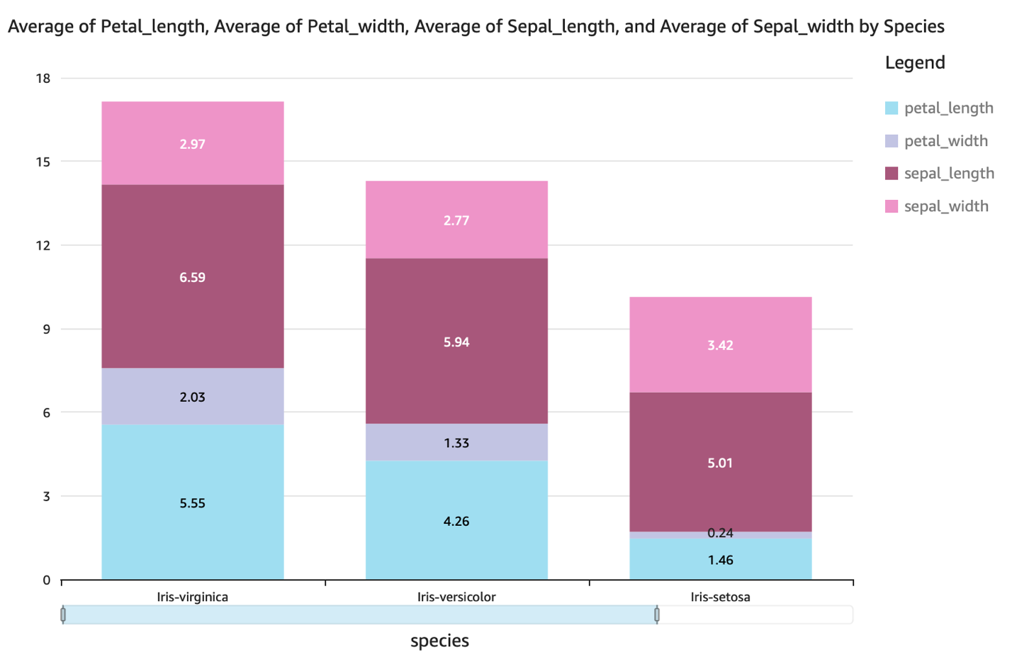

Insights:
- Size Differences: Iris Virginica displayed the largest aggregate measurements, indicating generally larger flowers, while Iris Setosa had the smallest.
- Species Differentiation: The differences in bar heights visually highlighted the distinct physical characteristics of each species, providing a quick comparison.

Histograms: Feature Distributions
Separate histograms were created for each feature (sepal length, sepal width, petal length, petal width) to examine their distributions.
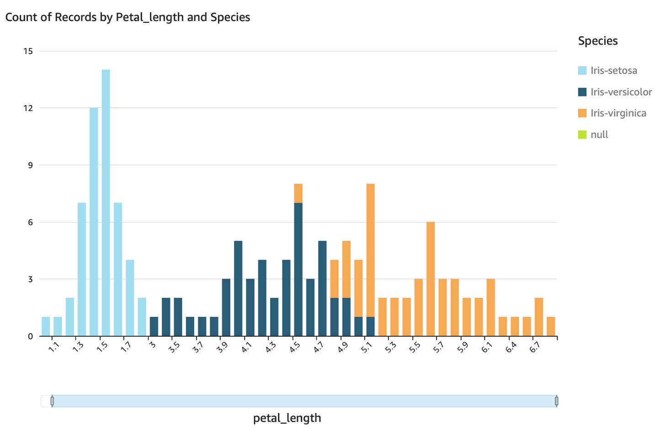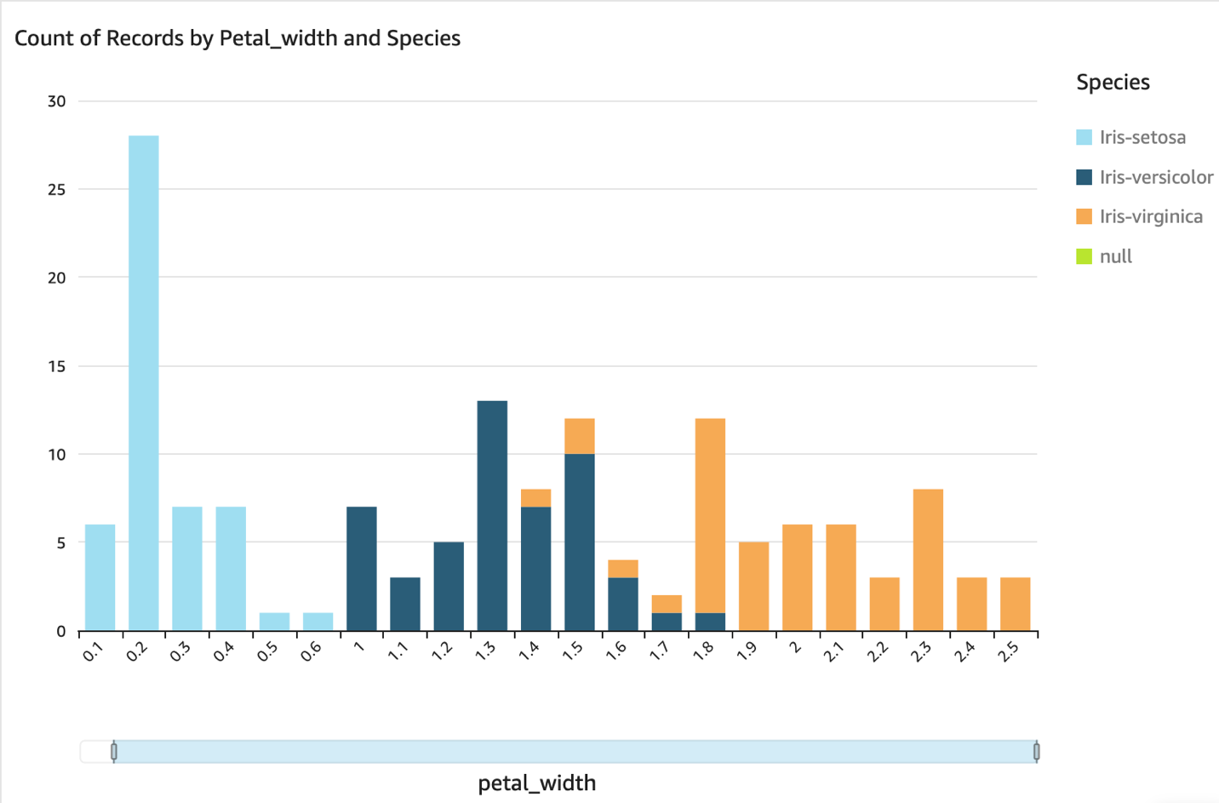
Petal Length and Width:
- Variation Among Species: The distributions for petal length and width revealed significant differences among species, with Iris Setosa having notably smaller petals and Iris Virginica having larger ones.
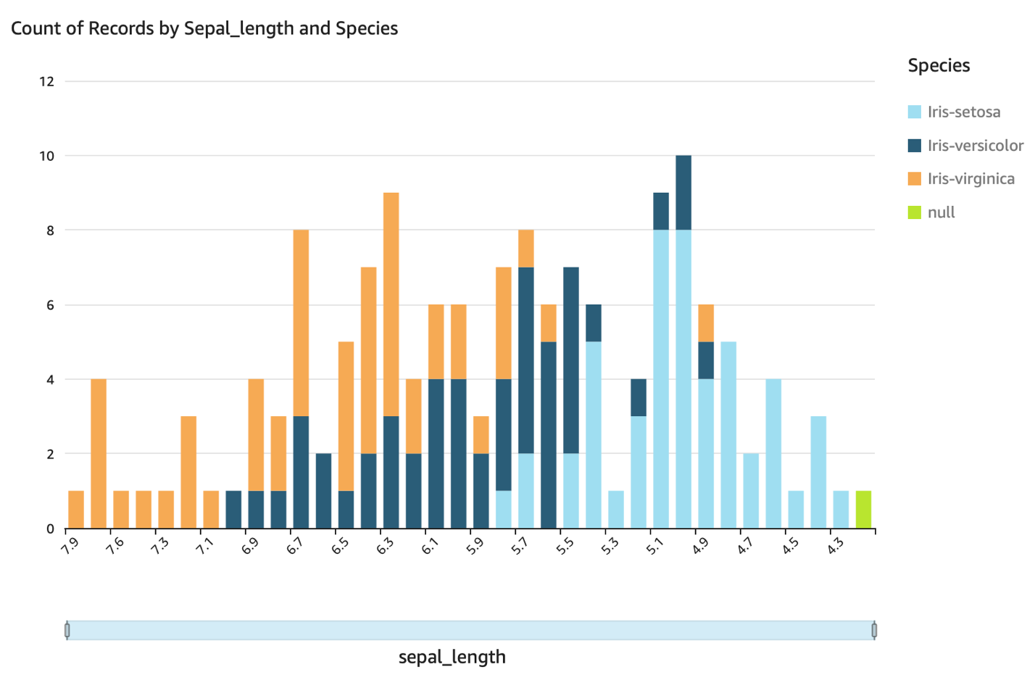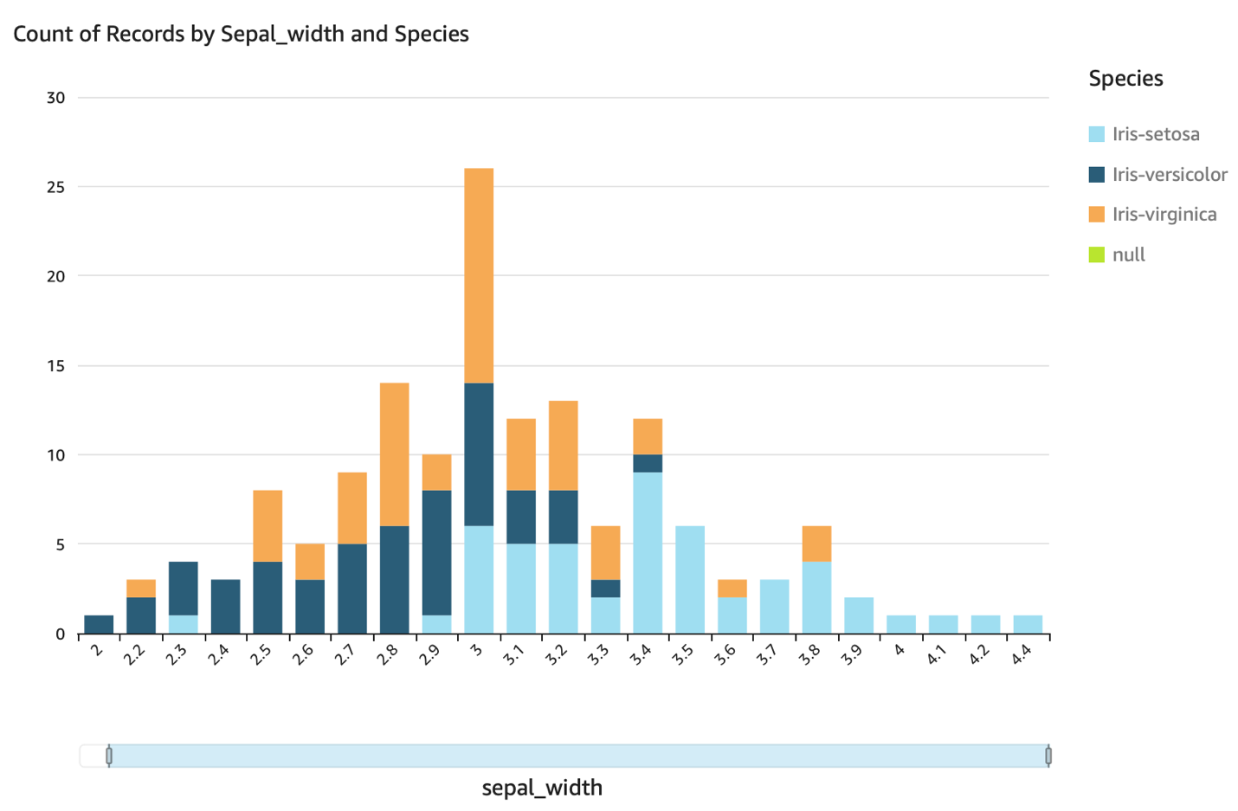

Sepal Length and Width:
- Distribution Patterns: The distribution of sepal lengths showed an approximately normal distribution with some skewness, while sepal width had a concentrated range. These patterns provided insights into the morphological diversity and commonalities among the species.

Scatter Plots: Feature Relationships

Petal Length vs. Petal Width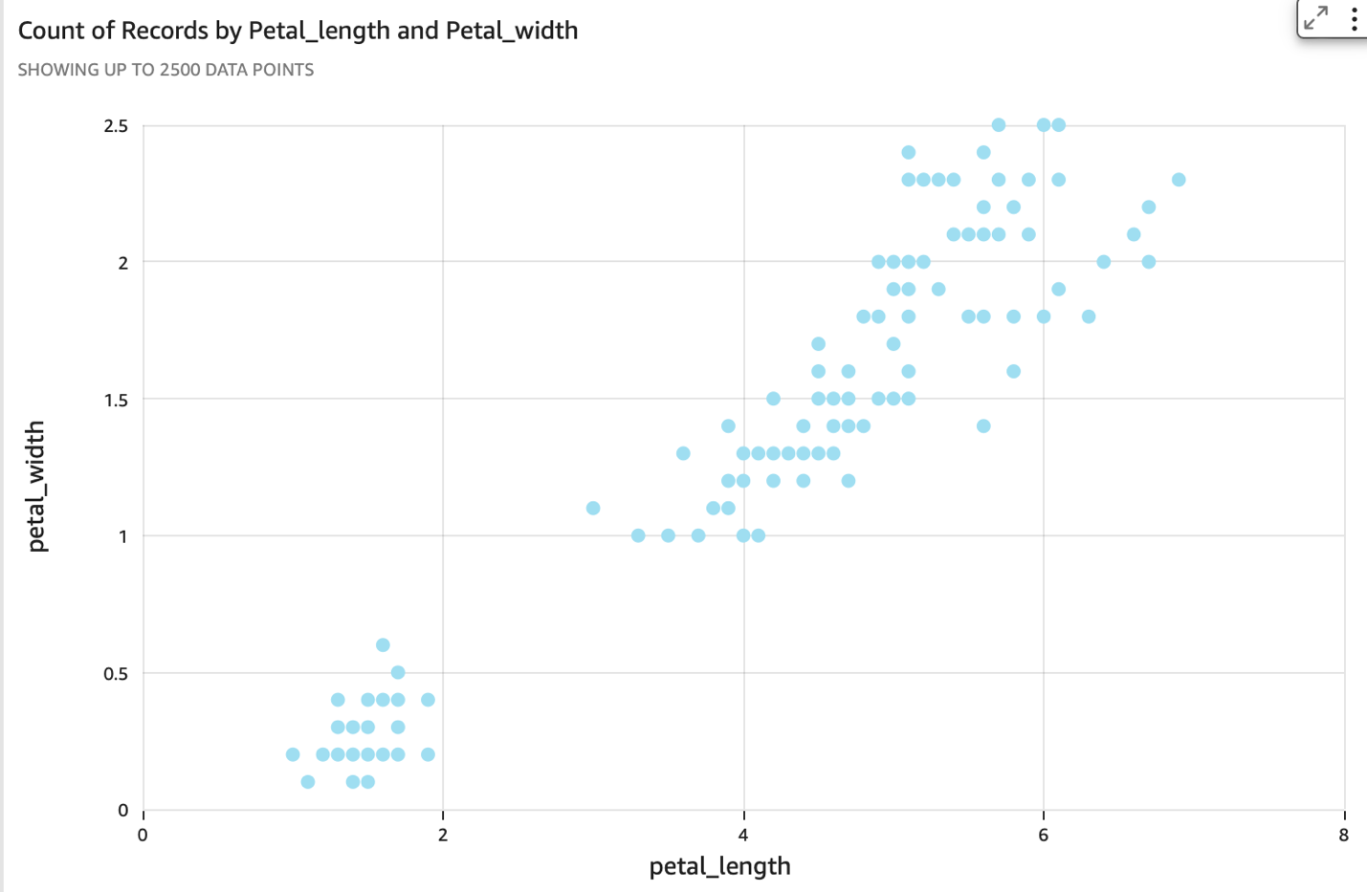
Insights:
- Correlation and Clustering: A clear positive correlation was observed, with distinct clustering by species. This plot confirmed the utility of petal measurements in distinguishing species.
Sepal Length vs. Sepal Width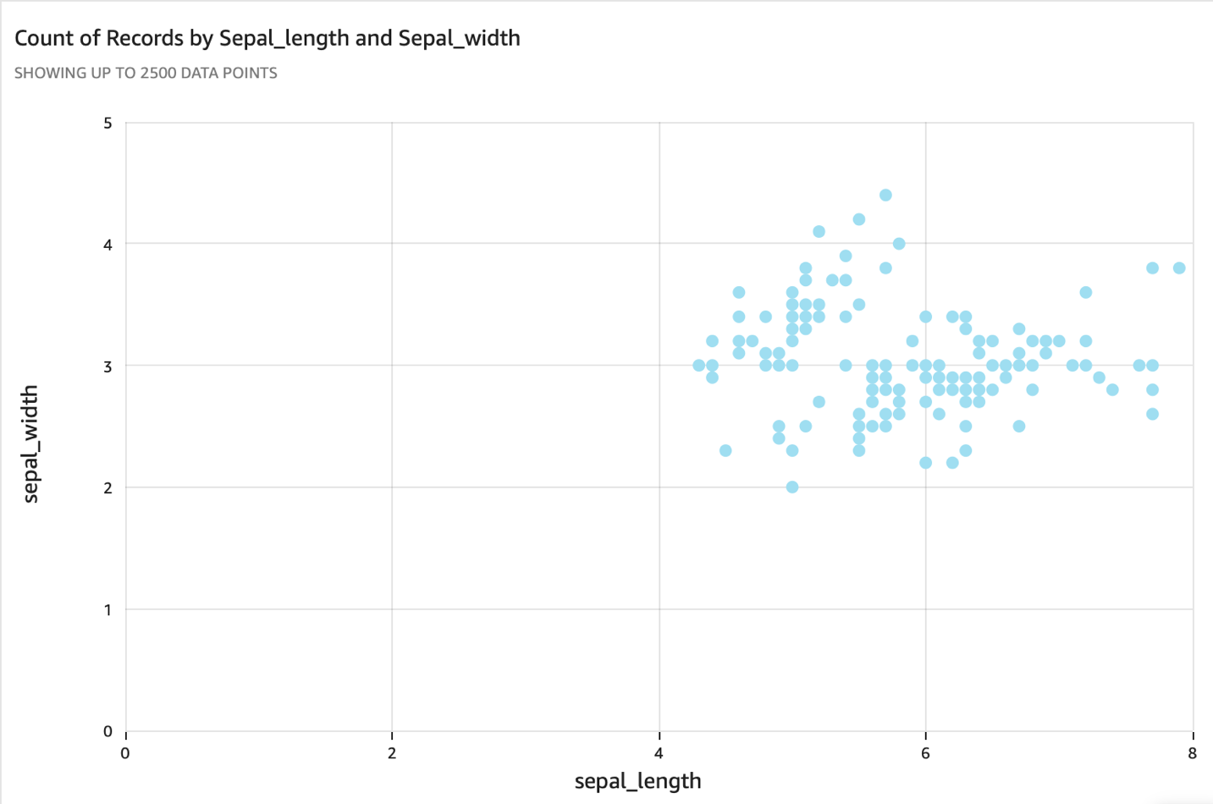
Insights:
- Moderate Correlation: Although less distinct than petal measurements, some separation was visible, particularly with Iris Setosa's shorter and wider sepals.

Petal Length vs. Sepal Length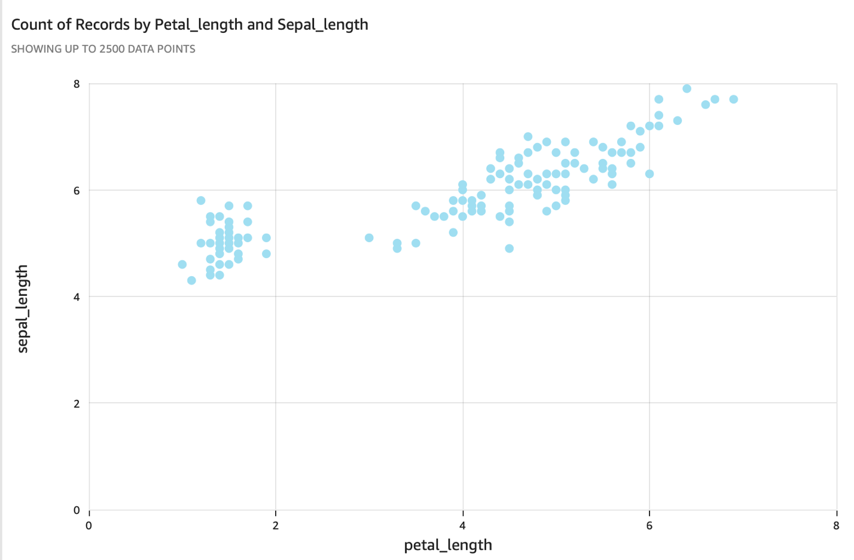
Insights:
- Interrelated Dimensions: This plot showed how petal and sepal lengths might be interrelated, providing further evidence for feature correlation across species.

Petal Width vs. Sepal Width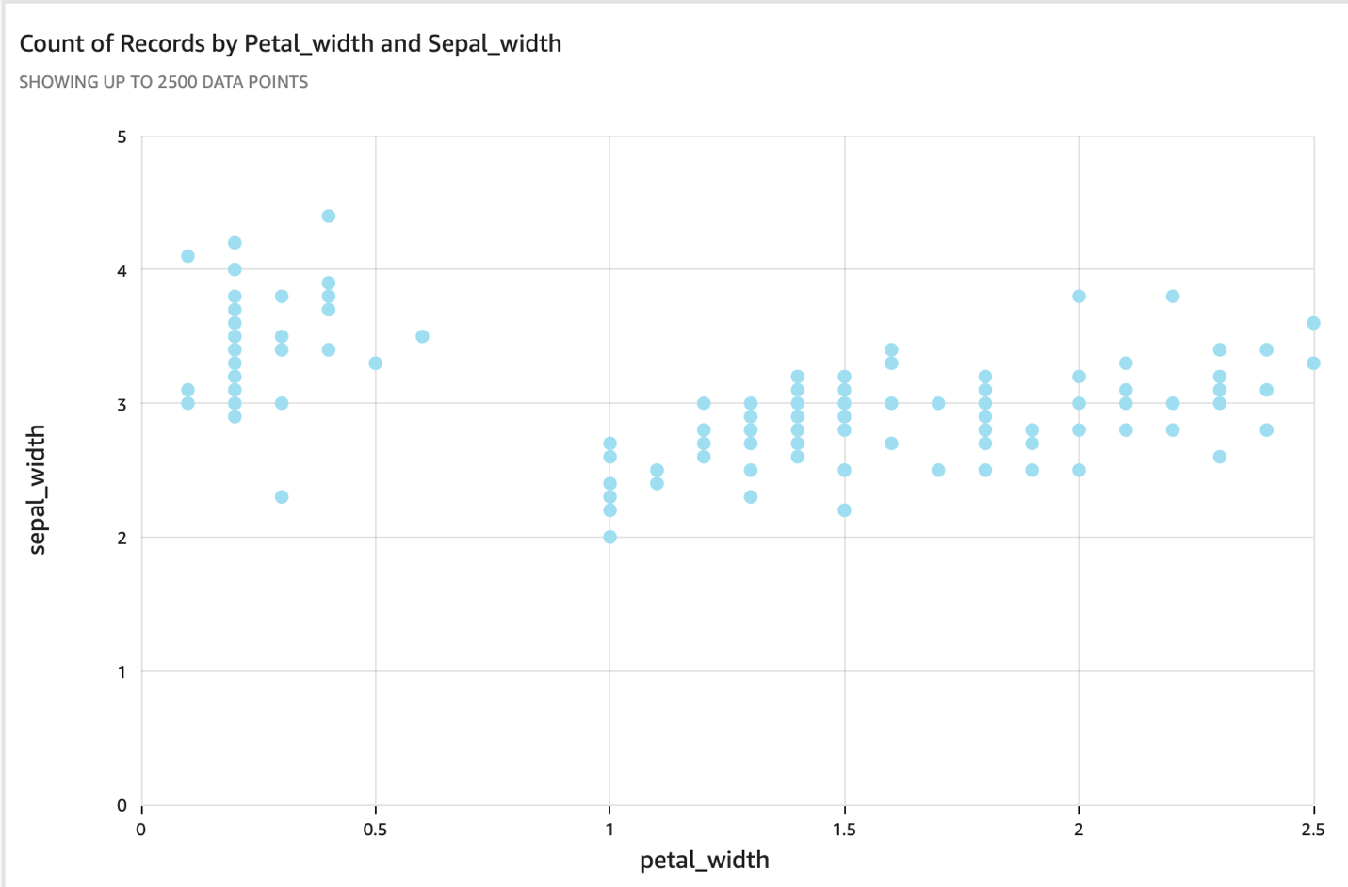
Insights:
- Unique Variation: Unlike other characteristics, the relationship between petal width and sepal width appeared varied, highlighting unique measurement variations across species.

Conclusion

The project successfully developed a comprehensive data pipeline using AWS services to process, analyze, and visualize the Iris dataset. Through this pipeline, significant insights into feature correlations and species classification were made. Future work could include implementing machine learning models to predict species based on new measurements, potentially enhancing the predictive capabilities of the analysis.

This paper provides a detailed account of each step in the project, from data ingestion to in-depth visual analysis, offering a replicable model for similar data science projects. The use of AWS technologies streamlined the data handling process, and the analytical queries and visualizations provided deep insights into the morphological characteristics of Iris species.

References
- Iris Dataset:
  - Fisher, R. A. (1936). The use of multiple measurements in taxonomic problems. Annals of Eugenics, 7(2), 179–188.
  - UCI Machine Learning Repository: Iris Data Set
- Amazon Web Services:
  - Amazon S3 Documentation: Amazon S3
  - AWS Glue Documentation: AWS Glue
  - Amazon Athena Documentation: Amazon Athena
  - Amazon QuickSight Documentation: Amazon QuickSight
  - Amazon SageMaker Documentation: Amazon SageMaker

